SEASONAL VARIATIONS IN BLOOD PRESSURE, NEUTROPHIL-LYMPHOCYTE RATIO AND WHITE BLOOD CELL COUNT IN A LARGE POPULATION OF PATIENTS WITH END STAGE RENAL DISEASE
A. Long¹, Z. Terner², J. Larkin¹, M. Reviriego-Mendoza¹, L. Usvyat¹, Y. Wang², P. Kotanko³, F.W. Maddux¹
¹Fresenius Medical Care North America, Waltham, MA, USA
²University of California Santa Barbara, Santa Barbara, CA, USA
³Renal Research Institute, New York, NY, USA

Background: Prior studies indicated that both blood pressure and mortality follow seasonal fluctuations in patients with end stage renal disease (ESRD) treated by hemodialysis (HD), although these findings were not confirmed in larger cohort. It is unclear if these seasonal patterns also occur and are related to seasonality in markers of inflammation.
Objectives: We investigated seasonal trends in pre-dialysis systolic blood pressure (SBP), pre-dialysis diastolic blood pressure (DBP), neutrophil-lymphocyte ratio (NLR), and white blood cells (WBC) in HD patients.
Methods: We collected data from HD patients treated at a large dialysis organization in the United States during 2010-2014. We developed a statistical model to simultaneously analyze seasonal effects and long-term trends due to changes over time while adjusting for time on dialysis. The method is flexible by fitting components nonparametrically using smoothing splines.
Results: Data from 305,918 patients was analyzed. Seasonal variations were observed in SBP, DBP, NLR and WBC (Figure 1 with detrended raw data). We noted peak-to-peak seasonal changes of approximately 2 mmHg for SBP, 1.2 mmHg for DBP, 0.2 for NLR, and 0.1 (1000/mc) for WBC.
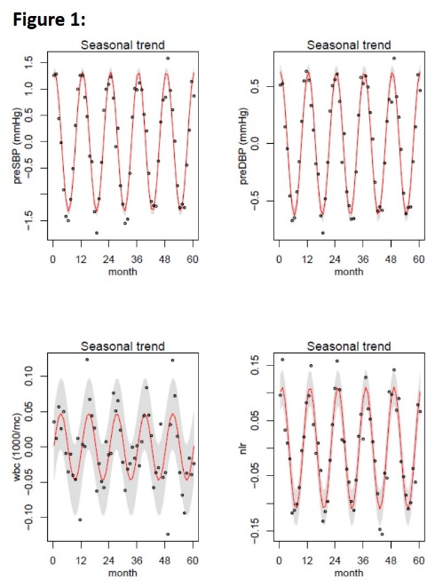
Conclusions: Findings suggest seasonal variations are present for SBP, DBP, NLR and WBC in a large cohort of ESRD patients, confirming previous results noted in the literature from smaller cohorts. The inflammatory marker of NLR may be associated with regulation of seasonal fluctuations in blood pressures.

